Contents

1. Introduction 2

1.1 Background and context 2

1.2 Scope and Objectives 2

1.3 Achievements 3

2. Specification 3

2.1 Task/Problem 3

2.2 Dependencies 5

2.3 Preprocessing 6

2.4 Global Threshold 6

2.5 Find Abnormal Objects 7

2.6 Local Threshold 7

2.7 Final Segmentation: 8

2.7.1 Watershed: 9

2.7.2 Morphological Separation of Nuclei Clusters: 10

2.10 Conjoin Regions of Interests 11

3. Evaluation 11

3.1 Thresholds 11

4. Results 13

5. Conclusion 21

5.1 Summary 21

5.2 Project Evaluation 22

5.3 Future work 23

Bibliography 24

# 1. Introduction

## 1.1 Background and context

Microscopy is the technical field of using microscopes to view objects that cannot be seen with the naked eye [18]. Light microscopy is the term used for microscopy where light is projected from a source on the opposite side of a sample to the objective lens. Once the light has passed through the sample, it is magnified by the lens and made visible to human vision. In recent decades, there have been significant developments in the field. At this point, it is a crucial tool to study subcellular level events. Usually a basic understanding of cell biology, and sample preparation is needed for optimal results. All of which is covered under histopathology.

Histopathology is the microscopic examination of tissue. In clinical medicine, it is often referring to the examination of biopsy or cultures by a pathologist. Histopathology is used in the diagnosis and treatment of patients. Tissues are processed, often with dyes, to separate different cellular structures, and then thin slices are taken and put between small sheets of glass for examination under a microscope. Features such as cell count and structure shape aid in the diagnosis of diseases like cancer.

Quick diagnoses are crucial for treatment of many diseases. As of now, histopathologists are manually completing tasks such as, counting cells, identifying nuclei, and segmenting clusters. This is true for the problem that this project intends to face. This project not only draws upon prior research into the segmentation of histopathological to shed light on appropriate techniques, but builds upon these past works. The data that this project is tested with are H400 microscopic images of oral cancer samples. The goal of this project is not to identify the cancerous cells, but to create an automated system for identifying and counting the cells in a given image. This would not only save pathologist time, but could prove crucial in timely patient diagnosis.

## 1.2 Scope and Objectives

The goal of this project is to build a system capable of autonomously segmenting microscopic images of cells into their respective nuclei. The output of which should be the number of nuclei in the image, and the outlines of the nuclei in the form of Regions of Interest (ROIs).

The objectives include:

* Identify nuclei
* Segment nuclei clusters
* Provide a nuclei count
* Create an ImageJ plugin for the system
* Better representation of cell shape than prior works
* Higher Accuracy than prior works

## 1.3 Achievements

This project was able to achieve nearly all of its goals. A plugin for ImageJ [16] was created and can successfully segment microscopic images of cells into its nuclei. The plugin provides a count for the number of nuclei that were found and saves the ROIs in the form of a TIFF image for later work. The plugin provides a high level of adaptability. Users are able to choose any combinations of thresholds within ImageJ, along with choosing the dye types that were used on their samples. When using the optimal parameters found in this paper the system was able to outperform both the Watershed method [2], and the prior work done by [6] in terms of identifying nuclei. The nuclei shape representation is also viewed to be on par with prior works.

# 2. Specification

## 2.1 Task/Problem

Over thousands of years, the human brain and eye have evolved to be very good at identifying distinct objects and discerning object depth. Unfortunately, computers have not had such a long time to develop such skills. Currently they have a hard time separating images, especially when overlapping and depth are involved. This proves to be a major hindrance when using computing to automate histopathological tasks. In a perfect case, there would be a slice of cells of exactly one cell deep. In this instance, there would be no overlap and the computer would simply have to separate the cells from the background. Real cases are not that easy, due to the three-dimensional nature of cells. Even with lab-grown samples, that have more regularity than natural ones, there is overlap between cells and irregular shapes. The overlap is where the true difficulty of the problem lies. Even after an area has been identified as having overlap, through approaches such as counting the number of concavities, how does one go about separating them? Many prior methods do a pretty good job at identifying the overlaps, but when they do separation the results have straight edges or regular ellipses/circles. Real cells do not have straight edges. The samples dealt with in this project are also cancerous, and do not all have a regular shape or size. This project aims to separate overlapped nuclei, but give the actual or close approximation to the shape of the overlapped cells. Achieving this will save pathologists many hours of manually reviewing microscopic images. It will also solve the problem of differences in opinion between pathologists when separating overlaps.

The task is broken down into five main sections: preprocessing of the microscopic image; identifying nuclei with a global threshold; detecting abnormality; further segment abnormalities with a local threshold; and final cell separation. Preprocessing of the image is found in virtually all projects in the field. In the case of this project images may have overlays that need to be hidden. The image also is processed so that the various methods within the system can perform on the image, but can do so at an optimal level. The actual processes performed are explained in detail in section 2.3.

Identifying of the nuclei should be the simplest of the sections. As mentioned before different dyes are absorbed by the nuclei and the surrounding proteins and the differences in color should be detectable with numerous methods. The original specification for this project planned to use thresholding of a clustering technique in the initial stage. Thresholding was chosen early on due to its simplicity, availability, and accuracy.

The original specification also planned on identifying nuclei clusters by techniques used in prior research such as the number of concavities [6]. Instead a combination of the average area and perimeter for a nucleus were used to identify area where further segmentation was needed. This eliminates problems that other works had when cells overlapped in such a way that there were no concavities. Also the dye absorption across the image was not found to be uniform and after performing the first segmentation with thresholding ROIs did not trend to be circular in nature. This would have cause a large number of ROIs to be segmented incorrectly or unnecessarily.

Originally the overlapping area of clustered nuclei was thought to be the feature used to segment clusters. The first specification theorized that that due the inherent translucence of cells the overlapping area would appear darker. This is visualized below in figure 1. The darkened area should be identifiable, and the true shapes of the nuclei can be recreated by combining the clusters outline with the outline of the overlapped area. During the early development of this project it was discovered that most clusters did not contain a clearly identifiable overlap, and subsequently the supposed method was no longer viable. Instead a local threshold was implemented to segment the overlaps.



Figure 1) Nuclei overlap

The local threshold performs admirably at segmenting clusters when the overlap is in the cytoplasm or there is an abnormal absorption of dye, but can’t actually segment overlapping nuclei. In light of this, a final segmentation method must be installed within the system. The [6] is the obvious choice considering that this project is an extension of that work, but due to time restraints the Watershed method [2] was implemented instead. Both methods are further explained in section 2.7.

## 2.2 Dependencies

ImageJ is an open source, Java-based image processing program. It was developed at the National Institutes of Health by Wayne Rasband [16]. Wayne is still responsible for the maintenance of ImageJ today. ImageJ has an open architecture that allows for extensibility through the development of plugins or macros. ImageJ has become the standard tool for working with microscopic images. This has led to the development of many useful plugins. Most of these plugins are open source and available on GitHub [20] or other source management sites. Distributions of ImageJ are available for most operating systems, including Mac OS, Windows, and Linux. ImageJ is extremely portable, it doesn’t need to be installed simply download the compressed file, extract to your desired location, and start the executable. There is an ImageJ plugin for the Eclipse [19] development environment making development of ImageJ plugins straightforward.

ImageJ has a record macro that automatically records the operations that a user performs when using the graphical interface. The macro can record the user’s actions into both a java plugin or ImageJ macro. This project opted for the development of a Java plugin, due to the extra functionality that developing in the Java language provides. The record macro proved extremely useful because it provided not only specific commands for operations but increased the learning curve of working with the ImageJ Eclipse plugin.

## 2.3 Preprocessing

In this section of the project the microscopic images are prepared for segmentation. There are three main processes: overlay removal, color deconvolution, and grey scaling. The first process, overlay removal, is only done if the file is a TIFF image. The reason for this is that TIFF images can have overlays to show things like ROIs. The TIFF files that are used in this project contain overlays of the gold standard nuclei outlines for the image. This gold standard for the image comes in the form of a stack of overlaid nuclei outlines in the form of ROIs. When the results of this project’s segmentation are shown on the image the overlays remain as well, making it much more difficult to read. Due, to this the first process is to tell ImageJ to hide the overlays. This is a built in function within ImageJ. Overlays can also be passed to the ROI manager for further experimentation.

The most important process that is done by this function is the color deconvolution. Color deconvolution splits the image into its separate dye colorations. This works by doing a vector subtraction on the RGB pixel values. The color vectors for each dye are subtracted from the image leaving the other dyes behind. This project makes use of the Color Deconvolution plugin [deconv plug]. This function comes with the color matrixes for commonly used dyes and allows for easy selection of these dyes with the input of their string representation. The preprocessing function that has been written for this project allows for the input of this string to allow for future work with different dye types, but for this project Hematoxylin and Eosin where used. The plugin produces three images: one for each dye; and a third for the subtraction of both. Hematoxylin is used to dye the nuclei of the cell while Eosin is used to color the cytoplasm. Since this project’s main objective is to identify the nuclei of the image the Hematoxylin image will be used. This image will appear as a blue representation of the original image, where the nuclei should appear more distinct.

The last step of preprocessing is to grey scale the image. In particular this project converts the image to an 8-bit gray scaled image. The operation was performed by the built in ImageJ function [16], but can easily be done within Java as well. Greyscaling needs to be done so that thresholding can be done in later steps. The thresholds that are used in this project work based on the grey intensities in the image, and thus need a greyscaled image to operate. The final greyscaled ImagePlus object is returned for use in other functions.

## 2.4 Global Threshold

The goal of this function is to identify the nuclei like structures within the image. This function should take in the ImagePlus object from the prior function. As described in the previous section this image should be greyscale. The second parameter that this function has is the thresholding method to be performed. In the case of this project, the parameter is the name of the method in string form. This is done in order for the method to be passed to the Auto thresholding method developed by Gabriel Landini [22] that also takes in the string name of the thresholding technique. The plugin comes with nine built in thresholding techniques. The method that has been chosen for this project is the Minimum method [17]. Both qualitative and quantitative methods have been used in the selection of this method, and are discussed in section four. After this threshold has been run, the resulting image should look like a mask of the nuclei. When looking at the image you should be able to see that the nuclei have been detected and depending on the thresholding method noise may be picked up as well. This image has both the “despeckle” and “fill holes” processes run upon it [16]. The “despeckle” command eliminates random outlining pixels and the “fill holes” command fills gaps within objects. These processes also convert the image into a mask, a needed transformation for accurate object analyzation.

The Minimum threshold [17] was the global threshold decided upon by this project. The Minimum threshold is extremely close to that of the Intermodes threshold. The method assumes a bimodal histogram and this histogram is smoothed using a running average of three. This iteration continues until there are only two local minima. This is where the two thresholds differ, the Intermodes threshold takes the midpoint between the two minima values, while the minimum threshold takes the lowest value between the two points.

## 2.5 Find Abnormal Objects

This section serves as a filtering between the normal sized nuclei and the areas that needed further segmentation. The mask is taken from one of the threshold methods and then analyzed to produce a set of ROIs. The ROIs are then filtered on both their area and perimeter to determine if they are abnormal in size. To determine where the cut off for these attributes should, be an average of the maximum values was taken from the gold standard measurements. The results of which were a perimeter of 226 pixels and an area of 3890 pixels squared. The normal and abnormal ROIs are then stored in separate files. The paths to these files are returned in an array list. The path to the abnormal ROIs is set to null if none were found. This method is run twice, once after each threshold.

## 2.6 Local Threshold

This section intends to further segment the abnormal areas. In the first threshold the greyscale values of the whole image are taken into account. As is often the case when working with natural structures, things do not work uniformly. In this scenario, the irregularity comes in the absorption of the dyes. Although the nuclei of a cell may still be much darker than the surrounding cytoplasm, it is still above the threshold. This is due to the threshold being set according to the values across the entire image. This leaves large ROIs that are identified in the abnormal method. To combat the uniformity of the global threshold, local thresholding is applied. The selected threshold is now applied to a smaller window of the image that is subsequently moved along. This project takes advantage of the plugin written by Gabriel Landini [21]. The plugin has nine built in local thresholds, the selection of which is done with their string name. The plugin also takes in a radius for the window size the threshold should be performed upon. This project keeps the radius at the default value of 15 pixels.

The image that this method takes in should be a duplicate of the original preprocessed image. Meaning that it should be deconvoluted and in greyscale. The abnormal ROIs from the previous step should be read in and combined. The area outside of this combined RIO should then be removed. To do this the ImageJ command “Clear Outside” is run [16]. This takes all pixels outside the selected ROI and sets it to the background color. In this project, that color has been set to white. This leaves an image containing only the abnormal areas. The local threshold is then run on these abnormal areas, and the resulting mask is returned. Akin to the first threshold method the “Despeckle” and “Fill Holes” commands are run on the thresholded image to create said mask.

The local threshold that is selected in this project is the Bernsen method [3]. This method uses a global threshold limit and local threshold limits to determine a pixel’s value. First the global threshold limit is set using the contrast threshold, the mean of the max and min grey values. Once this threshold limit has been set, the pixels of the image are looped through. A window of n * n centered at the current pixel is used to calculate the homogeneity of the area. The difference between the maximum and minimum values is used to judge this homogeneity. If the difference is greater than the global threshold limit, then the window is heterogeneous. A local threshold limit is then set to contrast threshold of the local limit, and the pixel value is determined from this. If the window is deemed to be homogeneous then the value for the pixel is set based on the global threshold limit.

## 2.7 Final Segmentation:

This method takes in the image produced by the local thresholding and the paths to the abnormal ROIs produced by the second call to the find abnormal method. Like in the local thresholding the ROIs are read in and combined, and then the outside area is removed with the “Clear Outside” command. This leaves the final areas to be segmented. Originally, the plan was to implement the previous work of the project owner and segment the final areas using Morphological Separation [6]. Unfortunately, by the time this project reached this stage in the development it was too late. The code wasn’t readily available, and there was not enough time left to implement it before the deadline. Instead, the most commonly used method for tackling this problem was installed. The Watershed method [2], that is already built into ImageJ, is used to do the final segmentation.

### 2.7.1 Watershed:

The Watershed transformation [2] is an image segmentation technique. The goal of which is to separate distinct objects within an image. The name Watershed comes from the transformation’s similarity to a geological Watershed, which is a ridge that divides the areas drained by different river systems. The Watershed transformation treats the image being used as a topological map. The brightness of each point represents its height on the map, and the transformation tries to find the line that runs along the top of the basin ridges. The Watershed method was first applied to image segmentation by Beucher and Lantuejoul [1] to segment images of bubbles and SEM metallographic pictures.

There are two kinds of Watershed methods. They differ on how the ridge lines are found. The first method is to use a flooding process. In [2], Beucher tells us to imagine that a hole has been put through each of the minima of a topographic surface. Then imagine that surface being slowly submerged in a body of water. Water will start to fill the surface by coming through the holes in the minima. As the surface floods, water from different minima may merge. That event is unwanted, so a dam is built where the two floods would merge. At the end of the flooding process, only these dams will reside above the water line. The dams are the watershed and separate the basins.

The second kind of Watershed finds the ridgelines by directly finding the Watershed points. There are multiple ways of detecting these points, one such way is based on the arrow representation of a function, described by Beucher in [2]. First from a function (f) of Z2 to Z the oriented graph can be made. The vertices of the graph are the points of Z2 and the arrows are drawn from a point, x, to an adjacent point, y, where f(x) is less than f(y). Arrowing can be performed by geodesic dilations and the operation is called the completion of the arrows graph. Watershed lines are not always of zero thickness, to overcome this over-completion is used. This results in double arrows for some points. Any point receiving arrows from more than one of its neighbors may be flooded by different lakes. This means that point may belong to a dividing line. Once these points are found, the arrows coming from these points must be suppressed. This changes the arrowing for the surrounding points and thus new divide points may appear. This process of suppression is repeated until no new divide points occur. At the end of this process local watershed lines are produced, but the true divide lines will be the ones that form closed curves.

The Watershed method works well with simple examples but often leads to over-segmentation. Meyer and Beucher came up with a solution for this using object and background markers in [10]. These markers tell the algorithm where the general minimum of an object resides, resulting in not every contour within an object being drawn. The watershed algorithm has been applied to the separation of nuclei clusters in [11]. In terms of creating the correct number of separations, the algorithm did very well with close to a 90% accuracy rate. The problems being difficulty handling large overlap and inaccurate representation of the cell shapes.

### 2.7.2 Morphological Separation of Nuclei Clusters:

Fouad, Landini, Randell, and Galton propose a morphology-based algorithm for separating clustered nuclei in [6]. The algorithm is split into four parts: Identifying potential nuclei clusters, concavity point detection, a region splitting algorithm, and morphological operations for cluster splitting. The first step is given a binary image of nuclei, within this image nuclei clusters are identified by their area. If an object's area is above an empirically determined value, then the object is identified as a cluster. Next, the concavity points in these large areas are located. This can be done mathematically using vector products. The most concave point is then selected based on its angle between contour points. The final list of dominant concave points is passed on to the region splitting algorithm.

The region splitting algorithm can be split into four parts itself. The first part is finding the convex contours. What this means is that the pixels along the convex segments connecting the concavity points are obtained. Next, least squares fitting [13] is used to fit circles to the convex segments, each of these circles represents an individual nucleus. The radii of the circles are restricted to the pre-calculated maximum radius of a nucleus, if the radius is found to be larger than this it is replaced with the maximum. In rare occasions, the center of a circle can be located outside the clustered region. To correct for this the center is repositioned slowly until it resides within the clustered area. At this point, the cluster is broken into overlapping circles, but often cells are an elliptical shape. To account for this the Euclidean distance between the centers of overlapping circles is measured, and if it is below a calculated value the two sections are merged. Finally, the overlapped nuclei are separated by mathematical morphology operations [4]. This is based on geodesic dilations of seeds that represent single areas belonging to candidate objects. This is similar to the aforementioned Watershed method [2], but instead of using eroded points as seeds, seeds are extracted from the regions containing convex segments and the centers of those regions.

During the evaluation of this method, it is compared to the Watershed method described in the previous section. The results indicated that it was marginally better than the Watershed method with respect to the number of nuclei in a cluster, but it fell short when representing the actual shapes of the nuclei. This method is prior work by the project owners, and the task of this project is to build upon the results of this work. Since the end goal is the same for this project, the initial steps should prove very useful in the identification of the clusters themselves.

## 2.10 Conjoin Regions of Interests

This section is where all the methods are pulled together. The two sets of normal ROIs along with the final set of ROIs from the Watershed [2] are all read in and overlay on the original image. The image is then saved as a TIFF file to the given save path.

# 3. Evaluation

Here the different methods of evaluation and the reasoning behind these evaluations will be discussed. There is both quantitative and qualitative evaluations throughout this project. The need for qualitative evaluation arises from the fact that the problem deals with vision and degree to which objects resemble their real world counterparts. As mentioned in the introduction and the breakdown of the problem, the cell images this project deals with are cancerous. Not only does this make the number of cells important but the actual size and shape of the cells becomes a factor in diagnosis. How well the outline of a shape matches another is difficult to quantify, but relatively easy for a person to make a decision on. Thus, the need for qualitative measures.

## 3.1 Thresholds

Both the Automatic Threshold [22] and Automatic Local Threshold [auto local thres] plugins have nine thresholding methods to select from. Both plugins also come with a try all option. This performs all nine of the thresholds and displays their results simultaneously within an image for quick examination. From the try all option, suitable methods will be selected for both the local and normal threshold. This selection will be done qualitatively based off how many of the nuclei seem to be selected and the amount of noise that is picked up.

The methods must then be evaluated quantitatively. It is difficult to test them separately because of their symbiotic relationship within the system. The results from the final system will have to be evaluated to determine the best combination. The images will be evaluated based on their difference in cell counts, accuracy rate, and their Jaccard Indexes [12]. Again, the number of cells in an image is an important factor in diagnosis, so the difference in cell count between the gold standard and the results of this project are to be minimized. The counts for the images are easily obtained by counting the number of overlays within each image. The absolute difference between the two will then be taken and averaged over the image set. This will give a general plus minus on the cell count for the combination of thresholds.

The Jaccard Index [12] is a statistic used for comparing the similarity of sample sets. It is defined as the size of the intersection divided by the union of the sets. This index is used widely in the field, and most prominently to this paper is used in the prior works of the problem owners. To achieve this index. Both the gold standard and the resulting image must be first converted into masks. The ROIs of both images are filled to either white or black and the background is made the opposite. The masks are then compared pixel by pixel recording whether they have the same value or not. Lastly, the true positives are divided by the sum of the true positives, false negatives, and false positives. Scores over 70 percent are deemed to be good.

The accuracy can be calculated at the same time as the Jaccard Index. The true values, both true positives and true negatives are divided by the total number of values. In this case that total will be the number of pixels in one of the images. This rate will generally be higher than the Jaccard Index because it accounts for the whole image as opposed to just the ROIs.

Ideally, there will be a pareto combination of algorithms. Meaning that the count difference accuracy, and Jaccard Index for a combination are better than any individual value for the other threshold combinations. This will not likely happen due to the fact that the three measures don’t necessarily correlate. The result could have a high Jaccard index, but not segment overlapping cells very well. For example, there may be a group of five overlapping nuclei and the project identifies this area, but only segments the area into two. This would still give a high Jaccard Index because the area has still been identified, but the difference in count would be three.

The last step will be to qualitatively evaluate the resulting images with the gold standards. This will be where the final decision is made. Combinations of thresholds will likely have similar quantitative results and the ability to accurately represent the nuclei will be the deciding factor. The methods to be used will most likely be decided by the developer’s preferences.

# 4. Results

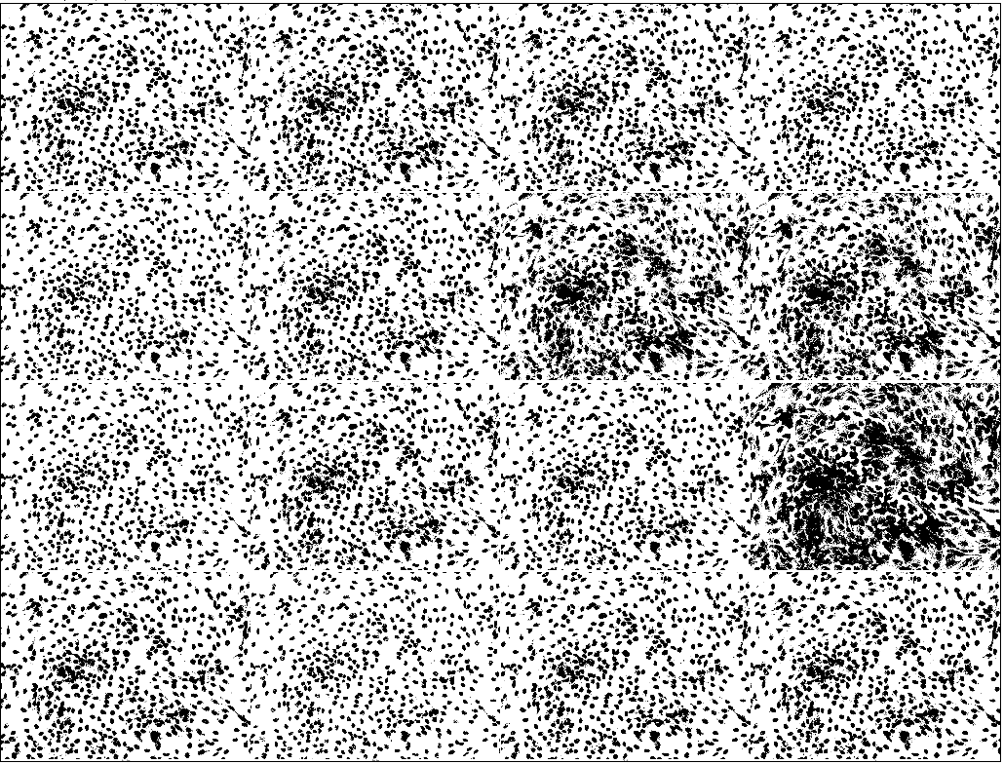

Figure 2) Global Threshold, From top left: Default, Huang, Intermodes, Iso Data, Li, Max Entropy, Mean, Minimum, Moments, Otsu, Percentile, Renyi Entropy, Shanbhag, Triangle

As mentioned in the prior section, the first evaluation is a qualitative eye check of the first threshold. In figure 2, all threshold methods have been performed on one of the images. The image has already been preprocessed. The goal of this check is to eliminate thresholds that obtain too much noise or not enough of the nuclei. The first thing that once should notice when looking at the thresholds is that none of the methods appear to under identify nuclei areas. The true problem lies in the detection of noise. This appears to happen the most when using the Percentile threshold [5]. In figure 2 this threshold is represented by the third image down on the far right. When looking at the image it is easy to see that the threshold picked up much more than just the nuclei. This leads to identifying noise as nuclei, which in turn lowers the accuracy of the segmentation and greatly effects the nuclei count difference. To prove this the threshold was tested anyway. The Percentile-Sauvola [5] [15] combination proved to be particularly bad, with an average nuclei count difference of 391.5. This an extremely large difference considering the actual nuclei counts range from mid 500s to the 600s. Further investigation into the reasoning for the difference found the combination of the amount of noise and the exclude parameter to be the problem. If the image is analyzed to exclude objects found on the edge, then the amount of noise causes many of the objects to be passed over. The exclude parameter works by ignoring objects that have a pixel along the edge of the image. Due to the amount of noise picked up by the Percentile threshold many objects are connected to such pixels, and therefore not taken into consideration. One may think that an easy solution to this is to simply include objects on the edge, but this causes more problems than it solves. When the Percentile threshold was used in segmentation with the edge objects included its lowest difference was 223 and its highest was 963. Now instead of not including most objects the image is being grossly over segmented. This is caused by a lot of noise being considered a nucleus. The under and over segmentation can be viewed below in figure 3. With these findings any threshold that is deemed to detect too much noise can be removed from the test set.

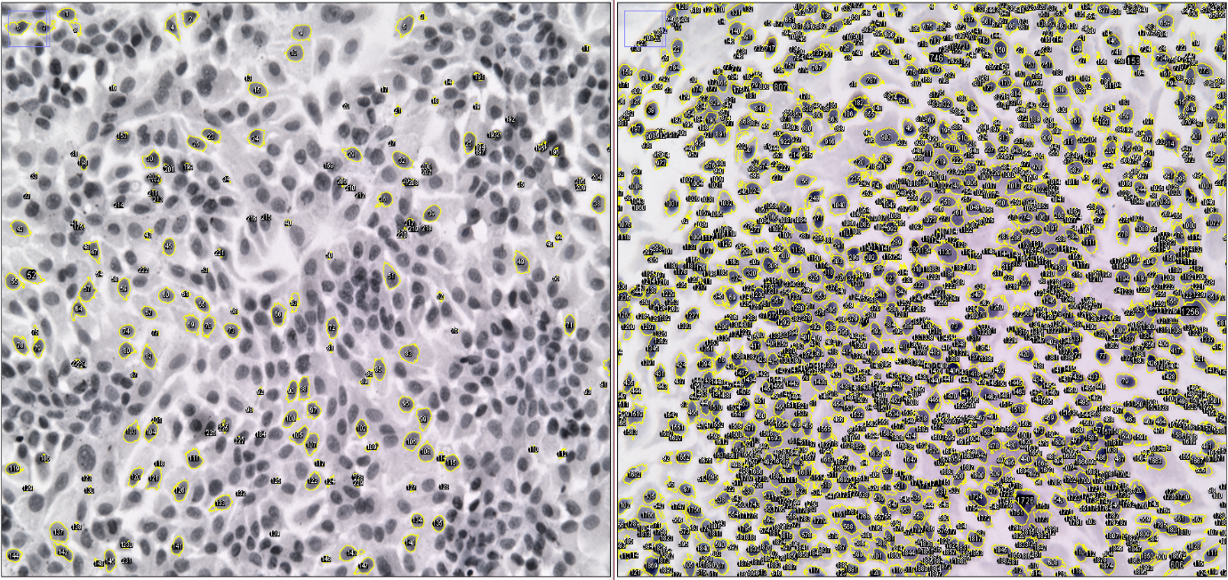

Figure 3) Exclude and Include Parameter comparison of the Percentile Threshold

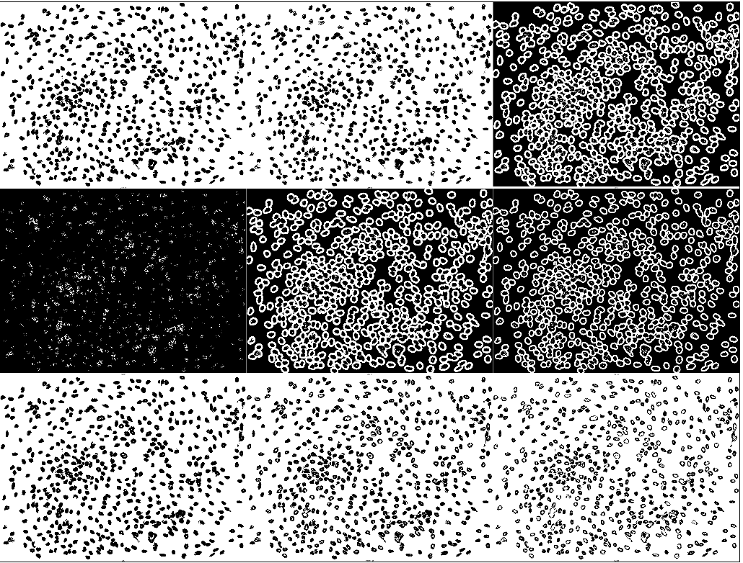

Figure 4) Local Thresholds - Berson, Contrast, Mea, Median, MidGrey, Niblack, Otsu, Phansalker, Sauvola

The next qualitative measure is the same as the last, but reviewing the local thresholding. To do this the thresholds must be tested on an image that has already undergone preprocessing and had one of the approved global thresholds already applied to it. Above, in figure 4, one can see the results of the nine local thresholds on an image that has undergone the Li threshold [9]. In the images within figure 4 all objects detected have been passed to the local threshold [21], but in the actual segmentation only objects of an abnormal size are passed on. This is not down in figure 4 to more easily demonstrate the faults in the thresholding techniques. The most obviously poor threshold is the Median threshold [8], the second image down on the left. The threshold has actually ended up doing the opposite of what is intended. Instead of further segmenting the ROIs, almost all pixels are identified as a part of an object. When this image is analyzed the gaps between the objects are what gets identified. This is obviously not what is intended by the project and the threshold can be removed from testing. The outlining effect that can be viewed in the top right image was initially concerning, but only the nuclei shapes where picked up when analyzed. It does cause problems when performing the Watershed method [2]. To solve this, the area outside the ROIs is subtracted to leave an image similar to that of the first two images in the figure 4.

When looking at the remaining images in the figure, those not displaying the outlining effect or over identifying, there isn’t a large difference. The most notable difference between them is the how filled the nuclei are. The images in the last row of figure 4 display varying degrees of this with the least filled threshold being the Sauvola in the bottom right. When this condition is mild it can easily be remedied by simple applying the “Fill Holes” command in ImageJ [16]. This doesn’t work as well when applied to a more extreme case like that of the Sauvola threshold [15]. The first image within figure 4 contains the results of performing the previously mentioned “Fill Holes” command on the Sauvola local thresholding. When comparing the image from figure 3 to that of figure 4 it can be seen that some nuclei are filled, but many are not. This is caused by the nuclei being so unfilled that there are gaps in the nuclei’s border and the fill command doesn’t have a true border to fill within. These unfilled nuclei cause further problems when performing the Watershed method. The Watershed serves to increasingly break down these already weak nuclei objects. A close up of this breakdown is displayed in the second image of figure 5. The majority of the lines breaking the boarder of the object are created by the Watershed. When the nucleus is analyzed it can be broken into as many as 11 objects. Consequentially, not only is the nuclei count going to be altered by this, but the large unfilled space will also lower the Jaccard Index and accuracy rates. On the grounds of that these thresholds hinder the overall accuracy of the system, they may be withdrawn from further testing.

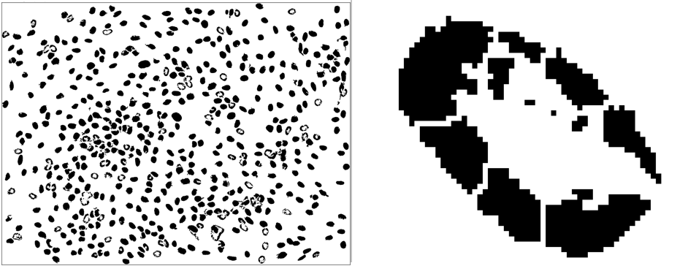

Figure 5) Results of using fillhole on Sauvola local threshold and close up of resulting watershed

Once the threshold sets have been minimized the combinations have to be evaluated quantitatively. As described in the evaluation section the Jaccard Index, accuracy, and difference in nuclei counts are used to measure the fitness of a combination. Even after minimizing the threshold sets there are still 91 possible combinations. To reduce the number of combinations having to be manually evaluated only the pareto combinations will be reviewed. A pareto combination is a thresholds pair that is not fully dominated. When pertaining to this project that would mean that no other combinations has both a higher accuracy, higher Jaccard Index, and lower nuclei count difference. This cuts down the combinations down to just four. The combinations are listed in figure 6, along with their average accuracy, nuclei count difference, and Jaccard Index. After looking at figure 6 it is easy to see that these combinations perform exceptionally well. All combinations have an accuracy rate of over 96 percent and with a difference of under 24 nuclei. The accuracy rate is slightly misleading because much of the image can be classified as “non-nuclei”. If one were to compare a purely black image to the gold standard the accuracy rating would be around 80 percent. In light of that, the combinations still perform very well identifying the rest of the 20 percent. The Jaccard Index is better in this regard as it doesn’t take the true negatives into account. The truly impressive accuracy measure of these combinations is the cell count. The average cell count in the gold standards id 640.25 nuclei. The highest average difference in nuclei count of the pareto combinations is just 23, making the average error just 3.6%. These accuracy ratings prove that all the pareto methods are more than competent enough. Considering that all the combinations are so equal quantitatively means the only way to pick a final combination will be to manually deem how well the shapes of the nuclei are outlined, and how well the overlapping nuclei are segmented.

|  |  |  |  |
| --- | --- | --- | --- |
| Combination | Average Accuracy | Average Count Difference | Jaccard Index |
| Triangle-Bernsen | 96.29% | 23.00 | 81.98% |
| IsoData- Bernsen | 96.29% | 20.25 | 82.04% |
| Minimum -Bernsen | 96.12% | 16.00 | 80.90% |
| Li-Bernsen | 96.20% | 17.25 | 81.34% |

Figure 6) Pareto Threshold combinations with average accuracy and nuclei count difference

The final qualitative measure is tailored to the preferences of the person doing the evaluation. In the case of this project the most important factors will be how well the actual shapes of the nuclei are represented. Before the evaluation is done there are two factors to take into account. Prior research in this area, including the Watershed method [2], have generally failed to represent a good shape for the nuclei when there are overlapping cells. Since this project has the Watershed method implemented within it, the outcome will generally be better in the combination that has a lower use rate. In most cases, it is plain to see where the Watershed method was used because the method creates straight or jagged segmentations. The second factor to reflect upon is that all pareto combinations use the Bernsen threshold as their local threshold. This will lead to many similar, if not identical segmentations. It is likely that the images will be nearly identical and differences will be hard sought after.

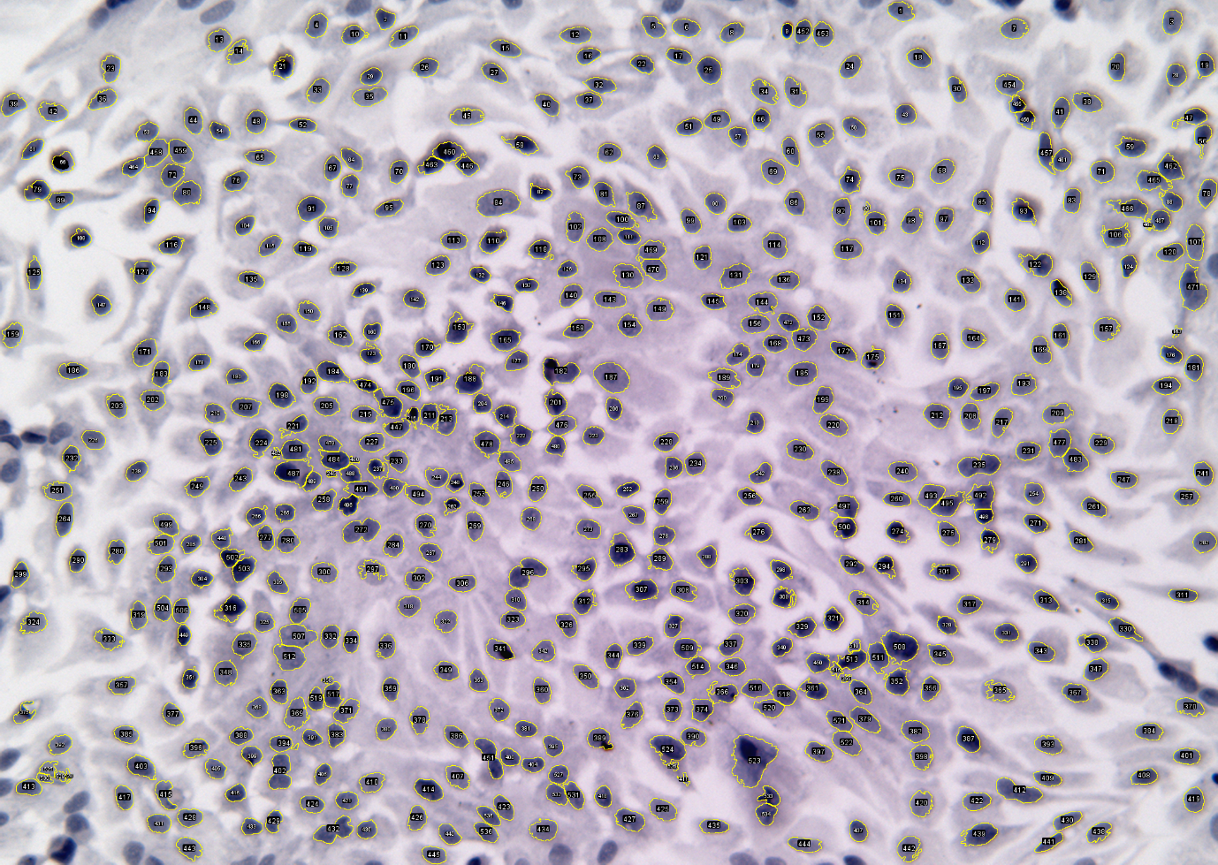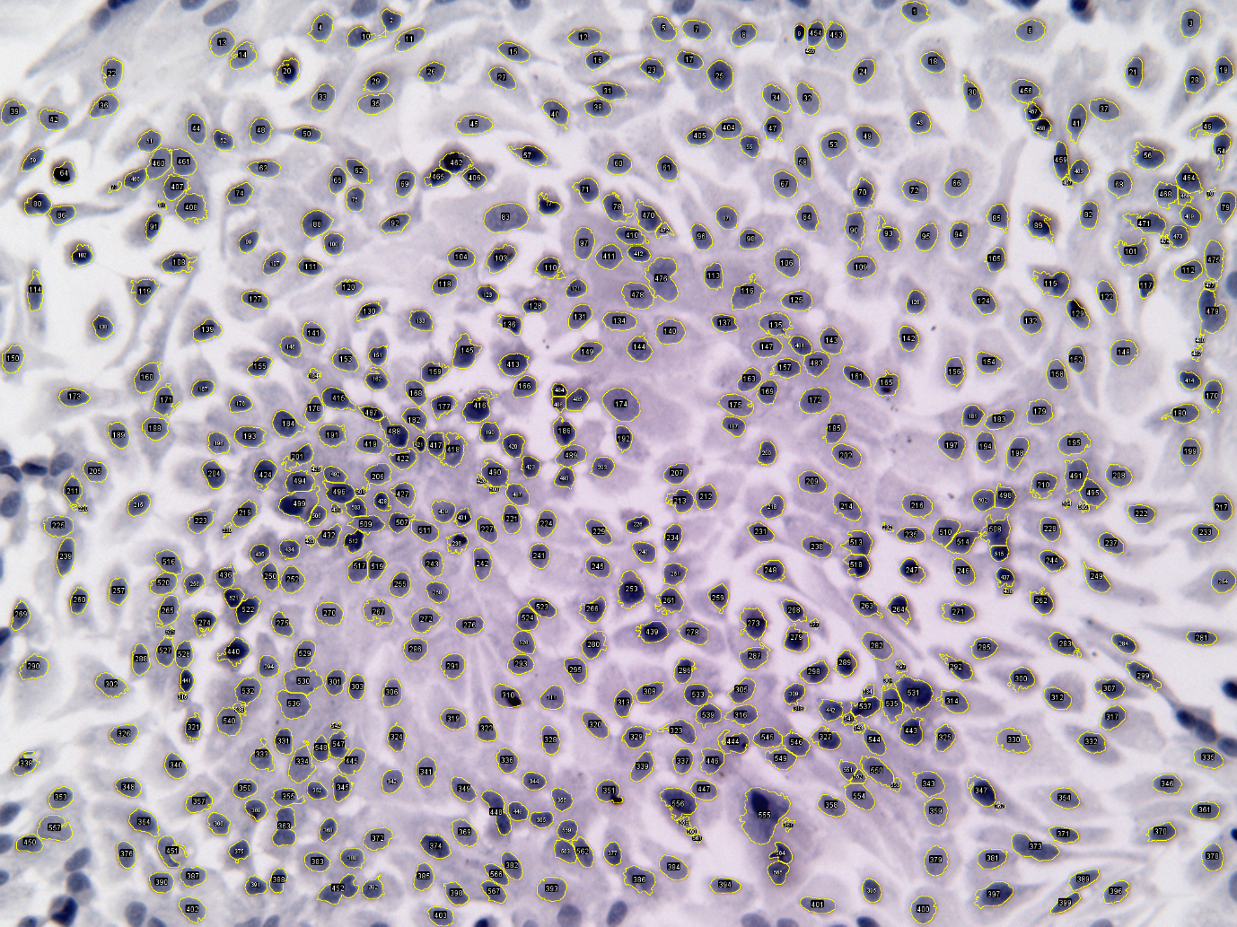

Figure 8) Li-Bernsen: h400_20_h000-overlay_nuclei

Figure 7) Triangle-Bernsen: h400_20_h000-overlay_nuclei

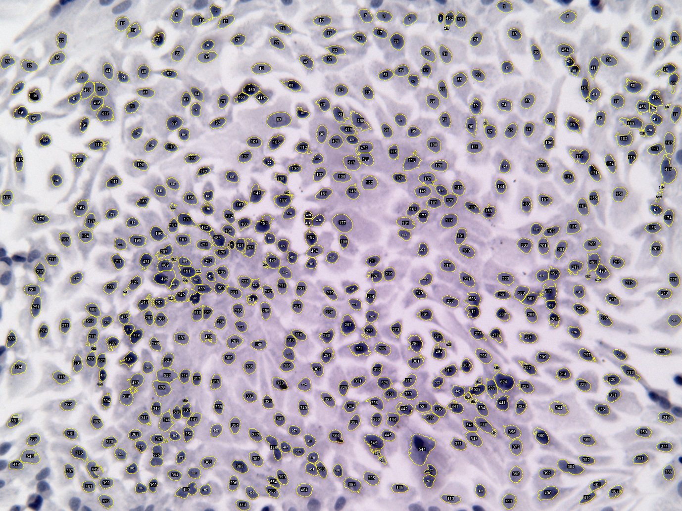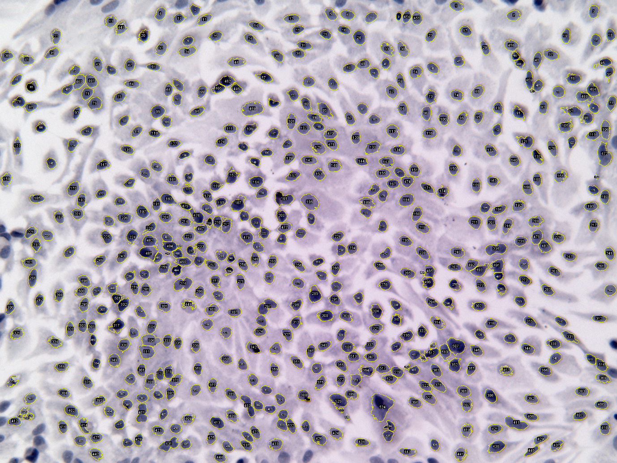

Figure 10) IsoData-Bernsen: h400_20_h000-overlay_nuclei

Figure 9) Minimum-Bernsen: h400_20_h000-overlay_nuclei

Figures 7-10 depict the segmentation of the “h400_20_h000-overlay_nuclei” image by the pareto combinations. As theorized the segmentations look nearly identical. A positive, that all the four images share, is that the majority of the nuclei that were missed are close to the edges of the image. The reason that this can be seen as a positive lies in the fact that there is a simple explanation for why they were not identified. When analyzing objects within ImageJ there is an exclude on the outside perimeter. The point of this parameter is to eliminate objects that don’t fully appear in the image. This is done by ignoring objects that have pixels on the edged. After thresholding nuclei may be grouped into one larger object. If this object contains any nuclei that are on the edge, then the whole object is considered to be on the edge as well. Within these images there are at least nine nuclei that can reasonably be assumed to fall into this scenario. This may seem like a small number, but one must remember how low the cell count differences for these combinations are. The Minimum-Bernsen combination [17][3] has an average difference of only sixteen, and subtracting the edge nuclei would more than halve the difference.

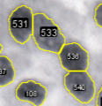

Figure 11) Watershed Segmentation

Earlier it is mentioned that the Watershed method [2] causes a decrease in quality of the nuclei shape representation. Above in figure 11 this can clearly be seen. As expected, this segmentation is found in all the pareto combinations, due to the fact that they share the same local threshold technique. The quality of the shape representation within figure 11 is not egregious, the worst segmentation being between 536 and 540. Between those two there is a very distinct straight line where there should clearly be two overlapping lines, but this is the price paid for implementing such a method. After reviewing all the images for the different combinations, all appear to use the Watershed method at an equal rate and in the same locations. This is assumed to again be caused by the use of the same local threshold. The use of the same local threshold was not an expected outcome and because of this the Watershed method use was expected to be a bigger contributing factor during qualitative evaluation.

After the observation of the Watershed use rate was made, other separating features needed to be reviewed. The two features that are used are noise pick up and edge nuclei detection. The least competent for these two features was the Triangle-Bernsen combination [23][3]. It was both less accurate at picking up nuclei on the edges, and also picked up the most noise. The Li-Bernsen [9] and IsoData-Bernsen [14] combinations were equal in terms of picking up nuclei near the edges, but the Li-Bernsen picked up less noise. The best in all features was the Minimum-Bernsen combination [17]. It picked up very little noise, and far outperformed the other methods at picking up the edge nuclei. This is reflected in the empirical data as well. If you look back at figure 6 you can see that the Minimum-Bernsen pairing had the lowest cell count difference. The fact that it had the best cell count is more impressive when taking into account that the other pairings’ combination of noise pickup and lack of edge detection actually cancel each other out and should boost the cell count difference.

In [6] the Jaccard index is used to evaluate their method, and the Watershed method [2]. The results were that the average Jaccard Index for their model was .74 and the Watershed was at .69. The paper finds the five percent difference a significant improvement in performance. This project was able to get an average Jaccard index of .81 far outperforming the Watershed method and the work done by [6]. The methods were not performed on the same data set, but a very similar one. Their dataset contained 2601 hand drawn nuclei outlines, whereas this project had 2561. Both data sets used the same image size and cell dyes. The similarities in datasets allows for this comparison to have merit. It is not believed that this one percent difference in size could account for a seven percent boost in performance. [6] also found their method to be superior to the Watershed method qualitatively. After reviewing the comparisons that were provided in their results and similar situations that this project faced, it is believed that this project performed equally for nuclei shape representation.

# 5. Conclusion

## 5.1 Summary

An ensemble of a global threshold, local threshold, and the Watershed Method [2] were used to segment microscopic images of oral cancer cells into their respective nuclei. The Minimum threshold [17] was chosen from a set of 16 global thresholds. It proved to be both qualitatively and quantitatively the best global threshold by identifying the most nuclei correctly, while also identifying the least noise. Irregularity in dye absorption proved to be too specific for a global threshold alone and a local threshold was implemented. The Bernsen local threshold [3] proved without a doubt to be the best technique. All pareto front threshold combinations used the Bernsen threshold. All pareto members performed extremely well with cell count differences with the gold standards below 4 percent.

Due to the nature of threshold techniques, segmentation of overlapped nuclei could be done in this problem. It was theorized initially that the translucence of cells would create a darkened area where overlapping occurs. When further explored this phenomenon occurred to infrequently for thresholding techniques to be a viable segmentation solution. In light of that discovery, the Watershed method was added to the ensemble. The Watershed method is a well-known technique in this problem field and is generally used as a baseline for other solutions.

The end solution to this project is an ImageJ [16] java plugin capable of segmenting microscopic images of cells into its nuclei. When tested against a dataset of 2561 cells the system was able to have average cell count differences below 4 % and an average Jaccard Index [12] of 81 %. This is a significant improvement empirically on the prior works discussed in this paper and therefore considered a success.

## 5.2 Project Evaluation

The main goal of this project was to create a system capable of segmenting an image of cells into its nuclei. This goal was achieved to a high degree. As discussed in 5.1, the system created in this project was able to produce an extremely low cell count error and a high Jaccard Index. All other goals, bar one, were achieved. A plugin was created for ImageJ that is capable of taking in an image of cells and outputting a TIFF image. The output image is segmented with the use of overlays. These overlays are easily transferable to the ImageJ ROI manager, and not only can statistics like cell count be retrieved, but useful measurements like perimeter and area can also be obtained.

The one shortcoming of this project was the goal to represent the nuclei shapes better than prior works. Other works have been able to achieve better representations than that of the Watershed method [2], and due to the use of that method within the ensemble have outperformed this project as well. The Watershed is the last segmentation within the system, and is used as sparingly as possible. In cases where the overlap is not between nuclei, but cytoplasm, the system can produce almost true representation. Over a whole image it is the opinion of this paper that the system created in this project is on par with other solutions when representing the shape of nuclei. Equal is not better by definition, and therefore the goal to be better has not been achieved.

## 5.3 Future work

The project may be deemed a success, but there can always be improvements. Firstly, further testing on a larger dataset should be done. Although the system was tested on a similar dataset size to that in [6], this is only 4 images. This would normally be deemed much too small for testing, but the number of nuclei and clusters within each image makes it viable. Even still further testing should be done. Test images can be made by anyone that knows the basic structure of a cell, but the nuclei must be outlined by hand and this is very time consuming. This project was under a time constraint, and when this system was developed enough to undergo further testing there was not enough time left to create more data.

A plugin for ImageJ was written, but was not fully integrated. What this means is that the plugin is only ready to be used from the Eclipse environment. Further code must be implemented in a main class so that this plugin can be run from the standard ImageJ. It would also be helpful to create a GUI for the system. Most plugins that have parameters other than the image to be performed on have a GUI for parameter selection. It would not be a lot of work to create one for this project’s plugin. It could be as simple as selecting the two thresholds.

Lastly, the final segmentation should be changed from the Watershed method [2]. It is mentioned throughout this paper that the original plan was to implement the prior work done in [6]. Fouad, Landini, Randell, and Galton [6] report that their method obtained a 5% better Jaccard Index, while also creating better representations of the nuclei shapes. This project already achieved a higher Jaccard Index than their method, but it is believed that swapping out the Watershed for theirs would further increase it. The betterment of the shape representation would also be appreciated. As mentioned in 5.2, this project is only on par with [6] due to the failings of the Watershed, so removing it should allow for the achievement of all goals.

# Bibliography

1. Beucher S. and Lantuéjoul C., "Use of watersheds in contour detection",

Int. Workshop on Image Processing, Real-Time edge and motion

detection/estimation, CCETT/INSA/IRISA, IRISA Report n°132, pp. 2.1-2.12,

Rennes, France, 17-21 Sept. 1979. [1]

1. Beucher, S. (1991). The watershed transform applied to image segmentation. Proc. Pfefferkorn Conf. on Signal and Image Processing in Microscopy and Microanal., Cambridge, UK, September [2]
2. Bernsen, J (1986), "Dynamic Thresholding of Grey-Level Images", *Proc. of the 8th Int. Conf. on Pattern Recognition [3]*
3. Dougherty, E.: Mathematical Morphology in Image Processing. CRC press. (1992) [4]
4. Doyle, W (1962), "[Operation useful for similarity-invariant pattern recognition](http://portal.acm.org/citation.cfm?id=321119.321123)", Journal of the Association for Computing Machinery **9**: 259-267, doi:[10.1145/321119.321123](http://dx.doi.org/10.1145%2F321119.321123) [5]
5. Fouad S., Landini G., Randell D., Galton A. (2016) Morphological Separation of Clustered Nuclei in Histological Images. In: Campilho A., Karray F. (eds) Image Analysis and Recognition. ICIAR 2016. Lecture Notes in Computer Science, vol 9730. Springer, Cham [6]
6. Fouad S., Randell D., Galton A., Mehanna H., Landini G. (2017) Unsupervised Superpixel-Based Segmentation of Histopathological Images with Consensus Clustering. In: Valdés Hernández M., González-Castro V. (eds) Medical Image Understanding and Analysis. MIUA 2017. Communications in Computer and Information Science, vol 723. Springer, Cham [7]
7. J. Fitch, E. Coyle and N. Gallagher, "Median filtering by threshold decomposition," in IEEE Transactions on Acoustics, Speech, and Signal Processing, vol. 32, no. 6, pp. 1183-1188, Dec 1984. [8]
8. Li, CH & Tam, PKS (1998), "An Iterative Algorithm for Minimum Cross Entropy Thresholding", *Pattern Recognition Letters* **18(8)**: 771-776 [9]
9. Meyer F. and Beucher S., "Morphological Segmentation", Journal of Visual Communication and Image representation, Vol. 1, n˚ 1, pp. 21-46, Sept. 1990, Academic Press. [10]
10. Malpica, Norberto, et al. "Applying watershed algorithms to the segmentation of clustered nuclei." (1997). [11]
11. P. Jaccard. Etude comparative de la distribution florale dans une portion des Alpe ´ s et du Jura. Bulletin de la Soci´et´e Vaudoise des Sciences Naturelles, 37(142):547–579, 1901 [12]
12. Pratt., V.: Direct Least-squares Fitting of Algebraic Surfaces. In: 14th Annual Conference on Computer Graphics and Interactive Techniques, Maureen C. Stone(Ed.), pp. 145{152. ACM, New York, NY, USA, (1987). [13]
13. Ridler, TW & Calvard, S (1978), "[Picture thresholding using an iterative selection method](http://ieeexplore.ieee.org/xpls/abs_all.jsp?arnumber=4310039)", IEEE Transactions on Systems, Man and Cybernetics **8**: 630-632
14. Sauvola, J & Pietaksinen, M (2000), "[Adaptive Document Image Binarization](http://www.ee.oulu.fi/research/mvmp/mvg/files/pdf/pdf_24.pdf)", Pattern Recognition **33(2)**: 225-236 [15]
15. Schneider CA, Rasband WS, Eliceiri KW (2012). "NIH Image to ImageJ: 25 years of image analysis". *Nat Methods*. **9** (7): 671–675. [16]
16. Tsai, W (1985), "Moment-preserving thresholding: a new approach", Computer Vision, Graphics, and Image Processing 29: 377-393 [17]
17. “What is Microscopy?” *The University of Edinburgh*, 20 Sept. 2016, www.ed.ac.uk/clinical-sciences/edinburgh-imaging/for-patients-study-participants/tell-me-more-about-my-scan/what-is-microscopy.
18. [www.eclipse.org/](http://www.eclipse.org/) [19]
19. [www.github.com](http://www.github.com) [20]
20. [www.imagej.net/Auto_Local_Threshold](http://www.imagej.net/Auto_Local_Threshold) [21]
21. [www.imagej.net/Auto_Threshold](http://www.imagej.net/Auto_Threshold) [22]
22. Zack GW, Rogers WE, Latt SA (1977), "Automatic measurement of sister chromatid exchange frequency", J. Histochem. Cytochem. 25 (7): 741–53, PMID 70454